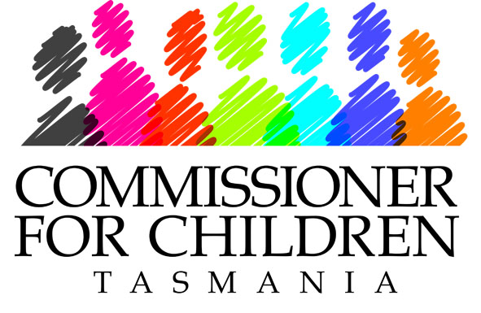
1st Floor, Stone Building,
ABC Centre, 1 Brooker Avenue,
Hobart TAS 7000
phone (03) 6233 4520
fax (03) 6233 4515
childcomm@childcomm.tas.gov.au
www.childcomm.tas.gov.au

Your Ref:
Our Ref: 346

22 November 2010

LGBTI Discrimination Consultation
Australian Human Rights Commission
GPO Box 5218 Sydney NSW 2001

Email : lgbti@humanrights.gov.au

Dear Australian Human Rights Commission

Protection from discrimination on the basis of sexual orientation and sex and/or gender identity

As Commissioner for Children in Tasmania the major focus of my role is to promote the rights and well being of children and young people, as well as providing advice to the portfolio Minister on policy, practice and services provided for children and young people. This also includes any laws affecting the well being and protection of children.

At the outset, I will make it clear that I support amendment of Federal anti-discrimination legislation to make it unlawful to discriminate on the grounds of sexual orientation and sex and/or gender identity. This would align Federal anti-discrimination legislation with the State anti-discrimination legislation and promote the enjoyment by all children and young people in Australia of their rights under international law and conventions such as the United Nations Convention on the Rights of the Child (UNCROC).

Specifically, Article 2 of UNCROC imposes an obligation on the government to ensure that all children and young people enjoy the rights described in that Convention without distinction or discrimination.

Article 13 protects a child’s right to freedom of expression, Article 14 protects a child’s right to freedom of thought, Article 16 to freedom from arbitrary interference with privacy and Article 19 obliges Australia to take steps to ensure children and young people are protected from all forms of violence and abuse.

Similar guarantees are found in other international instruments to which Australia is a party.

Studies cited in the Commission’s Discussion Paper support the view that gay, lesbian, bisexual, transsexual and intersex people experience unacceptable levels of discrimination, violence, harassment, bullying and abuse and experience higher levels of anxiety and depression.

According to the Executive Summary of a recent major report:

A large majority of non-heterosexual people do not suffer from depression or any other mental disorder; however, most of the studies reviewed indicated a higher risk for depression, and various outcomes associated with it, in non-heterosexual people. The results of this literature review point to strong trends towards higher rates of depression, more depressive symptoms, and poorer mental health outcomes for non-heterosexual people when compared with heterosexual people. Young non-heterosexual people clearly show significantly higher prevalence of depressive symptoms than their heterosexual counterparts. The literature also points to alarming rates of abuse and victimisation of young non-heterosexual people and, further, significantly higher rates of suicidal behaviour when compared with heterosexual young people. Although the results are less consistent for gay, lesbian and other homosexually active adult women and men, the data are still compelling. The theme that runs throughout this review is the effects of homophobia and heterosexism on the mental health of non-heterosexual people. In many ways, this points to a burden of poor mental health that may well be entirely preventable.

In addressing depression for non-heterosexual people, the most effective response will be to institute measures to combat homophobia and discrimination in the general community and seek to level out many of the differences documented in this report. [my emphasis].

I endorse the above conclusion and rely on it to support my strong view that the legislative prohibition of discrimination on the grounds in question should be seen as a priority for Government and that legislative action should be complemented by community education programs and other awareness raising measures.

I am available to discuss my submission in more detail if that would be of assistance and look forward to the release of the Commission’s Report.

Yours sincerely,

Aileen Ashford
Commissioner for Children

Discussion Paper Australian Human Rights Commission “Protection from Discrimination on the basis of Sexual Orientation and Sex and/or Gender Identity; October 2010; footnotes 2, 3 and 4.
J Corboz, G Dowsett, A Mitchell, M Couch, P Aguis & M Pitts, Feeling Queer and Blue: A Review of the Literature on Depression and Related Issues among Gay, Lesbian, Bisexual and Other Homosexually Active People, Australian Research Centre in Sex, Health and Society, La Trobe University (2008).

